Diet Regularity on Emotional Wellbeing

Liv Tissot
University of Essex Online
Psychobiology and Neuroscience
13.09.2026

Word count: 2151

Proposal Declaration
I, Liv Tissot,
Declare that this proposal has been composed solely by myself and that it has not submitted, in whole or in part, in any previous application for a degree. Except where stated otherwise, by reference or acknowledgment, the work presented is entirely my own and has been generated by me as the result of my own original research.
Signed:
Date: 13.09.2026

Abstract
Regular meal timing is one of the factors which determine our wellbeing. Our body enjoys routine, and consistent eating schedules help us set our circadian rhythm. This proposed study considers whether regular meal times will influence our emotional wellbeing, and how sex differences affect this.
Using an experimental between-subjects design, 256 participants will be recruited from social media platforms to take part in a 14 day experiment. The participants will be randomly assigned to the control or test groups, where the test group is given allotted meal times. Participants will record their meal times and fill out the WHO-5 Wellbeing Index each day, and this data will be analyzed in IBM SPSS Statistics, using a two-way independent ANOVA test.
It is hypothesized that participants in the test group will score higher on the WHO-5 , and that women will show a significantly higher difference between the test and control groups. This proposed study will add to the pool of existing literature surrounding diet and wellbeing, and provide valuable insight on the specific role of routine eating habits on emotional wellbeing.

Introduction

Literature review
Eating habits, including deviant eating behaviour such as regularly skipping meals or overeating has a significant association with mental wellbeing (Morshed et al, 2022). The extent of this wellbeing is prompted by several factors, one is the motivation associated with the dietary patterns we follow (Nestorowicz et al, 2020). These habits which encompass the consistent frequency of our meals are tied to our overall brain function, including; slowing cognitive decline, stronger neurodevelopment, and emotional wellbeing (Granero & Guillazo-Blanch, 2025).
The gut-brain axis connects the gastrointestinal (GI) system and the central nervous system (CNS), this connection greatly impacts emotional wellbeing (Patil et al, 2025). Alongside our Circadian Rhythm the GI forms a loop which influences our gut microbes, and helps us in maintaining our sleeping cycles. Our eating habits also serve to regulate our emotions through lowering stress hormones such as cortisol. The creation and maintenance of one’s gut microbiome affects our emotional and neurological health, making healthy eating patterns important to maintaining ourselves. One of the factors which influences this is regular meal times (Kim et al, 2025).

The Circadian Rhythm is known to have sex differences. According to Walton et al (2022), some of these differences include physiological responses such as body temperature, heart rate, and in the Hypothalamic Pituitary Gonadal (HPG) Axis and Hypothalamic Pituitary Adrenal (HPA) Axis. Lok et al (2024) support this by highlighting that the differences in Circadian Rhythm also modulate metabolic control, which affects nutrition, energy production, and energy balance.
Moreover, Diez-hernandez et al (2026) explain that sex has a significant effect on dietary habits, and the resulting effect on wellbeing. With women overall exuding a higher prevalence of deviant eating patterns, as well as psychological issues related to food. These findings highlight the importance of considering not only the quality of the diet but also its consistency.

Rationale
The proposed study aims to support the literature on the effect of lifestyle on wellbeing. We expect predicted findings to support the existing literature on the differing dietary effects between men and women (Imamura et al, 2015: Mauro et al, 2020), as well as the effect of diet regularity on wellbeing (Appleton, 2018: Gershon & Margolis, 2021).
There is a research gap in the effect of diet regularity on emotional wellbeing as the only independent variable (IV). Some studies, such as Bedache et al (2021) or Jimenez-Morcillo and Clemente-Suarez (2023) investigate the different relationships sexes have towards healthy living and wellbeing, however, these studies consider the impact of several different variables including strength-training and lifestyle. This leads to our research question: “Is greater consistency of meal timing associated with emotional wellbeing in young adults, and is this relationship moderated by biological sex?”
Hypothesis: “Participants in the test group with regular meal times will score significantly higher than the control group on the WHO-5 wellbeing index.”
Hypothesis: “Women will demonstrate a significantly higher difference between the test and control groups compared to men.”
Null hypothesis: “There will not be a significant difference between groups.”

Research design

Design
This study is using an experimental between-subjects design. Participants will be divided by sex before being randomly assigned to the test or control groups which will be compared to see whether the independent variable (IV) has a significant impact on the dependent variable (DV). The control group will have standardised meal times, while the test group will not. Meal timing variance will be recorded alongside the WHO-5 wellbeing index and will be completed each day.

Materials
The apparatus needed for this study includes the WHO-5 wellbeing index, as seen in Appendix A, Qualtrics, and SPSS. The WHO-5 wellbeing index is a 5 question index measured on a scale from 0-5, where 0 indicates low wellbeing and 5 indicates high wellbeing. The scoring of this index ranges from 0 to 25, this score is then multiplied by 4 to have a percentage out of 100%. A score below 50 is considered an indicator for poor mental health (WHO, 2024).
The platform Qualtrics will be used to record the data. It is an online hub for academic surveys which will allow participants to answer the WHO-5 and record their meal times each day, which can be seen in Appendix B. SPSS will be used for data analysis, as it is considered to be the ideal tool for this within social sciences (Rahman & Muktadir, 2021).
Finally, a consent form, as shown in Appendix C will be provided during the recruitment phase. This form will explain what will be expected of participants and give them the chance to opt out of the study. It will include a debriefing and explain the right to withdraw as well as how their data will be kept anonymous.

Participants
In order to achieve standard statistical power we will use quota sampling to recruit 256 participants, with 64 in each group. With this we can test for a medium effect size. Participant recruitment will take place through social media as this is an efficient and cost effective strategy when recruiting young adults (Darko et al, 2022). Facebook and Instagram have proven to be efficient in finding specific populations to recruit (Smith et al, 2023) and will be employed for this process.
Participants will be within the traditional young adult ages of 20 to 35, and they must have no history of insomnia or any health concerns regarding dietary choices, such as diabetes, nor irregular sleep schedules, as these can disrupt the circadian rhythm (Gentry et al, 2021).

Data analysis plan
To prepare for data analysis we must clean the data set within SPSS. We ensure the data is nominal, and search for errors or outliers. Next, we run descriptive statistics, as seen in Appendix D, and frequencies to ensure all the data points fall within the correct scale, and to handle any missing entries. Once this is completed, we can begin our data analysis.
To do this, we use a two-way independent ANOVA, which is the appropriate test for two IV’s. This test will show us three things, which are: the main effect of each IV, and the interaction effect. To prepare for the test, we create three columns, one with sex, one with condition, and one with test scores. Both latter columns must be coded with labels.

To demonstrate this, we have randomly generated data using SPSS, and performed the two-way independent ANOVA, Table 1 and Table 2 show us the average test results for each IV on the DV, and Table 3 shows us a summary of the averages.

Table 1
Univariate tests (Sex)
Univariate Tests
Dependant Variable: Scores
 | Sum of Squares | df | Mean Square | F | Sig.
Contrast | 0.03 | 2.00 | 0.02 | 0.008 | 0.99

Table 2
Univariate tests (Condition)
Univariate Tests
Dependant Variable: Scores
 | Sum of Squares | df | Mean Square | F | Sig.
Contrast | 9.76 | 2.00 | 4.89 | 2.29 | 0.10

As the Sig. scores of Table 2 and Table 3 are greater than 0.05 they are not statistically significant.

Table 3
Sex*Group

Sex*Group
Dependant Variable: Scores
Sex | Condition | Mean | Std. Error | Lower Bound | Upper Bound
Women | Control | 2.24 | 0.19 | 1.88 | 2.62
Women | Test | 2.29 | 0.18 | 1.93 | 2.65
Men | Control | 2.57 | 0.19 | 2.21 | 2.94
Men | Test | 2.45 | 0.18 | 2.10 | 2.81

Figure 1
Sex*Group Means
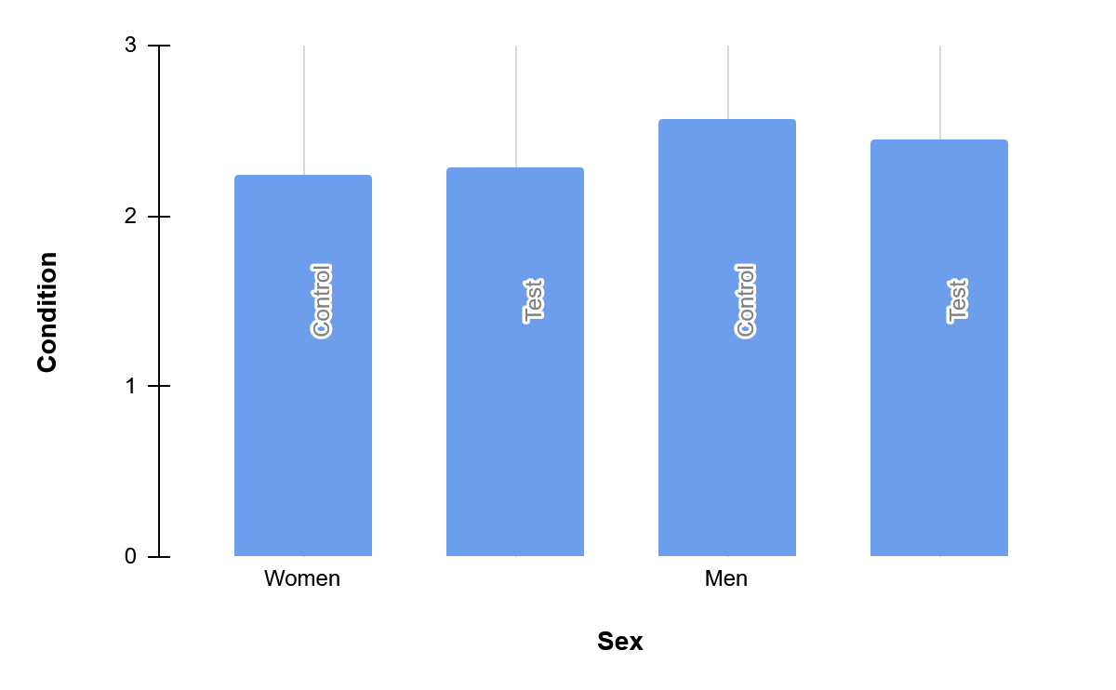
Figure 1 gives us a visual representation of the mean scores for each condition. While our randomly generated data is not statistically significant and we fail to reject the null hypothesis. If the study were to be conducted, we would expect to see significant data and a greater variation in the bar graph.

Procedure
To begin, a Qualtrics survey will be created, and the contents of the WHO-5 wellbeing Index, will be added to it, as well as an open answer question to record meal times.
Following this, we must recruit participants. Using facebook and instagram a total of 256 participants will be recruited and assigned to the control or test groups using stratified randomization, to have an equal number of men and women in each group.
Informed consent will be gathered through a consent form, which will include a debriefing about the experiment, as well as informing the participants about the right to withdraw and giving them access to the researcher’s contact information concerning any further questions they may have.
Once the participant quota has been met, we can begin the experiment. Over a 14 day period, the participants will record their meal times, as well as their WHO-5 wellbeing index score and record these in a qualtrics survey. Once the collection period ends, the data analysis takes place in SPSS using a two-way independent ANOVA test, this allows us to search for a significant relationship between the IV’s and the DV.

Ethics
In order to conduct this study we must meet the ethical standards. This includes gaining informed consent, clarifying the right to withdraw, and ensuring data anonymity. In order to achieve this, an online consent and debriefing form will be provided, which will require a signature before the test can begin. A debriefing will be written out for the participants, ensuring they are aware of the purpose of the study and their right to withdraw.
Due to our design requiring the control groups to have assignment meal times, we must be able to ethically justify this. The British Psychological Society (BPS) requires risk assessment. For this study, meal timing is an essential IV which is necessary to conduct the experiment. In order to mitigate harm, the instructed meal times will fall within the bounds of normal life, without causing metabolic drops. Populations with health concerns will be excluded from the experiment. This will be explicitly made clear within the consent form in order for the participants to understand what is expected of them and whether they feel they are suited to the study.
Ethical approval will be gained from the University of Essex Online, Department of Psychology, ensuring that the research will adhere to The BPS (BPS, 2021) standards.

Limitations
There are several limitations to the proposed study. First, using a between subjects design has some constraints, including the need for a large sample size to achieve statistical power. Furthermore, individual differences between participants, such as age, mood, or metabolism can be a confounding variable on the results. We mitigate this by randomly assigning participants to a condition.
Additionally the participants are at risk of a self-report bias, wherein their answers are not entirely accurate to what is real. Moreso, there are confounding variables such as life stressors outside of the experiment, which could affect the answers given on the wellbeing scale.

Timeline
Table 4
Proposed Research Timeline
Work Package | Main Activities | Indicative Timing
1. Literature review and Research Protocol | Find a research gap and the aim of the study.  Finalise measures, procedural and material needs. | Week 1-3
2. Ethics Review | Submit proposal for ethics review.  Address any concerns. | Week 4-8
3. Recruitment and data collection | Recruit participants.  Manage data collection. | Week 9-13
4. Data preparation and Analysis | Process data.  Perform statistical tests. | Week 14
5. Report write-up | Write the report.  Write an abstract. | Week 15-19
6. Review | Have the report reviewed by the supervisor.  Address any concerns. | Week 20-23
7. Submission | Finalise and submit. | Week 24-26

References
Appleton, J. (2018, August 1). The Gut-Brain Axis: Influence of microbiota on mood and mental health. https://pmc.ncbi.nlm.nih.gov/articles/PMC6469458/
Begdache, L., Sadeghzadeh, S., Derose, G., & Abrams, C. (2020). Diet, Exercise, Lifestyle, and Mental Distress among Young and Mature Men and Women: A Repeated Cross- Sectional Study. Nutrients, 13(1), 24. https://doi.org/10.3390/nu13010024
Code of Ethics and Conduct | BPS. (n.d.). BPS. https://www.bps.org.uk/guideline/code- ethics-and-conduct
Darko, E. M., Kleib, M., & Olson, J. (2022). Social media use for research participant recruitment: Integrative literature review. Journal of Medical Internet Research, 24(8), e38015. https://doi.org/10.2196/38015
Gentry, N. W., Ashbrook, L. H., Fu, Y., & Ptáček, L. J. (2021). Human circadian variations. Journal of Clinical Investigation, 131(16). https://doi.org/10.1172/jci148282
Gershon, M. D., & Margolis, K. G. (2021). The gut, its microbiome, and the brain: connections and communications. Journal of Clinical Investigation, 131(18). https://doi.org/10.1172/jci143768
Granero, R., & Guillazo-Blanch, G. (2025). Nutrition and Dietary Patterns: Effects on brain function. Nutrients, 17(7), 1169. https://doi.org/10.3390/nu17071169
Imamura F, Micha R, Khatibzadeh S et al. Dietary quality among men and women in 187
countries in 1990 and 2010: a systematic assessment The Lancet Global Health, 3, e132-e142
Jimenez-Morcillo, J., & Clemente-Suárez, V. J. (2023). Gender Differences in Body Satisfaction Perception: The role of nutritional habits, psychological traits, and physical activity in a Strength-Training population. Nutrients, 16(1), 104. https://doi.org/10.3390/nu16010104
Kim, Y., Kim, E., Lee, Y., & Park, J. (2025). Role of late-night eating in circadian disruption and depression: a review of emotional health impacts. Physical Activity and Nutrition, 29(1), 018–024. https://doi.org/10.20463/pan.2025.0003
Lok, R., Qian, J., & Chellappa, S. L. (2024). Sex differences in sleep, circadian rhythms, and metabolism: Implications for precision medicine. Sleep Medicine Reviews, 75, 101926. https://doi.org/10.1016/j.smrv.2024.101926
Lombardo, M., Aulisa, G., Padua, E., Annino, G., Iellamo, F., Pratesi, A., Caprio, M., & Bellia, A. (2019). Gender differences in taste and foods habits. Nutrition & Food Science, 50(1), 229–239. https://doi.org/10.1108/nfs-04-2019-0132
Morshed, M. B., Kulkarni, S. S., Saha, K., Li, R., Roper, L. G., Nachman, L., Lu, H., Mirabella, L., Srivastava, S., De Barbaro, K., De Choudhury, M., Plötz, T., & Abowd, G. (2022). Food, mood, context: Examining college students’ eating context and mental well-being. ACM Transactions on Computing for Healthcare, 3(4), 1–26. https://doi.org/10.1145/3533390
Nestorowicz, R., Jerzyk, E., & Rogala, A. (2022). In the Labyrinth of Dietary Patterns and Well-Being—When Eating Healthy Is Not Enough to Be Well. International Journal of Environmental Research and Public Health, 19(3), 1259. https://doi.org/10.3390/ijerph19031259
Patil, S., & Mehdi, S. S. (2025). The Gut-Brain Axis and Mental Health: How Diet Shapes our Cognitive and Emotional Well-Being. Cureus, 17(7), e88420. https://doi.org/10.7759/cureus.88420
Rahman, A., & Muktadir, M. (2021). SPSS: an imperative quantitative data analysis tool for social science research. International Journal of Research and Innovation in Social Science, 05(10), 300–302. https://doi.org/10.47772/ijriss.2021.51012
Smith MVA, Grohmann D, Trivedi D Use of social media in recruiting young people to
mental health research: a scoping review BMJ Open 2023;13:e075290. Doi: 10.1136/bmjopen-2023-075290
The World Health Organization-Five Well-Being Index (WHO-5). (n.d.). https://www.who.int/publications/m/item/WHO-UCN-MSD-MHE-2024.01
Walton, J. C., Bumgarner, J. R., & Nelson, R. J. (2022). Sex differences in circadian rhythms. Cold Spring Harbor Perspectives in Biology, 14(7), a039107. https://doi.org/10.1101/ cshperspect.a039107

Appendix A
Items of the WHO-5 Well Being Index
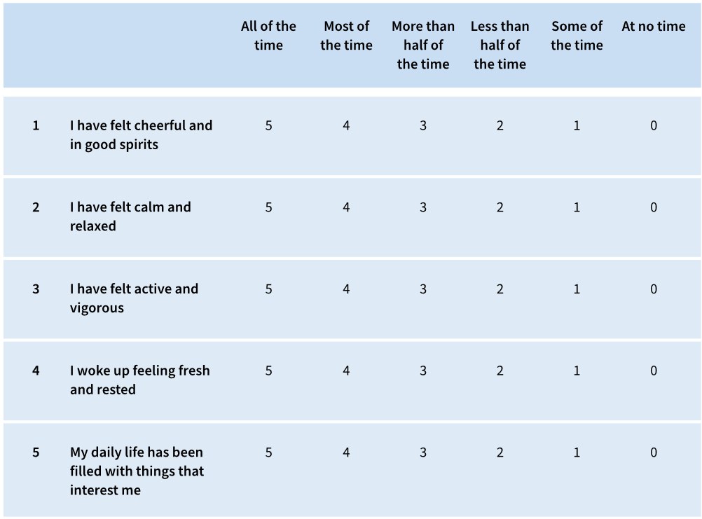

Appendix B
Link to Survey Preview
Qulatrics - Survey Preview (Diet Regularity on Emotional Wellbeing)

Appendix C
Consent Form and Participant Information Sheet
Figure 1
Participant Information Sheet
PARTICIPANT INFORMATION SHEET
Project title: Diet Regularity on Emotional Wellbeing
Name of student researcher: Liv Tissot
Institute: University of Essex Online
This research is being conducted as a student research project as part of a postgraduate psychology degree.
Please read the information provided to you before taking part in the research. Your understanding of the purpose of this research is important and you may want to discuss the information with the researcher as well as clarify any information.
What is the purpose of the research?
The purpose of this study is to investigate the effect of regular meal times on emotional wellbeing. We are interested in understanding the role of routine meal times in maintaining our wellbeing.
Why have I been asked to take part?
As an adult between the ages of 20 to 35 with no history of medical issues, you meet the selection criteria to take part in this study.
What do I have to do to take part?
Your participation is voluntary and you do not have to take part in this research if you do not want to. If you do decide to take part in this research you will be asked to document your meal times over a 14-day period and complete the WHO-5 Wellbeing Index daily. You will be asked to use the Qualtrics platform to record these and will need to have access to the internet and a device to access the platform over the two weeks.
Depending on the group you have been assigned to, you may be asked to rearrange your meal times to fit a specific schedule. If this is not possible for you, you may withdraw from the study.
What is the benefit of me taking part?
By participating in this study you will help the researcher develop skills in how to conduct an experimental study, as well as expand the pool of existing literature surrounding the management of emotional wellbeing.
What are the risks of me taking part?
As you may be asked to change your eating schedule, it is possible that you will experience fatigue and mood changes due to the disruption of your internal clock. However, you will not be asked to go for long periods without eating and all scheduled meal times will take place within regular daytime hours.
Can I withdraw from the project?
Your participation in this project is entirely voluntary and you may choose not to take part. If you do choose to take part, you can withdraw at any time during the study without having to give a reason and with no penalty.
If you wish to withdraw yourself or your data please contact the lead researcher using the email address given. If you ask to withdraw, your data will be identified and removed from the dataset. It will not be included in any analysis or used at any point.
How will my data be used?
Data will be combined with the data of other participants to conduct a qualitative data analysis. Your data will be anonymised and no identifying features will be made public at any time.
Who will have access to my data?
Only the research team will have access to your data and any data will be stored securely in a password protected computer.
Will I be identified within the report?
At no time will you be identified within the report. Your data will remain entirely anonymous and used only for the purpose of data analysis.
Who should I contact if I have any questions?
If you have any questions regarding the study, please contact the researcher at the email address below.

Name of researcher: Liv Tissot Contact email: lt25497@essex.ac.uk
Name of Supervisor: _______________ Contact email: ________________

Figure 2
Consent Sheet
PARTICIPANT CONSENT FORM
Title: Diet Regularity on Emotional Wellbeing
Please tick or initial the relevant box to indicate your agreement with each of the statements:
 | Yes | No
I confirm that I have read and understand the participant information sheet provided to me.
I understand that I am voluntarily participating in a research study and that I am free to withdraw without giving reason.
I understand the risks that may result in participating in this research.
I understand how my data will be used and stored and who will have access to this data.
I understand that my identity will not be revealed and the data I provide will be anonymised.
I understand I can withdraw from the study at any time and do not need to provide a reason. To do so, I need only notify the researcher.
I was provided the opportunity to ask questions and my questions have been answered to my satisfaction.
I consent to participating in this study, according to the information provided in the participant information sheet.
Initials: ____________ Signature: ________________ Date: _____________

Appendix D
Descriptives
Descriptive Statistics
Descriptive Statistics
 | N | Minimum | Maximum | Mean | Std. Deviation
ControlGroupWomen | 64.00 | 0.00 | 5.00 | 2.20 | 1.40
TestGroupWomen | 64.00 | 0.00 | 5.00 | 2.51 | 1.44
ControlGroupMen | 64.00 | 0.00 | 5.00 | 2.30 | 1.52
TestGroupMen | 64.00 | 0.00 | 5.00 | 2.45 | 1.48
Valid N (Listwise) | 64.00

